ClearQuote Technologies India Pvt Ltd
All rights reserved

Exercise 1: Real time detection

Summary Problem Statement
Below are the overlays used to help users capture images of a car. In order to check in real time whether the user has captured the right image or not, we need a solution that works on the edge (on a mobile device) and confirms if the frame / image captured by the user matches the requirement (defined by the overlay)

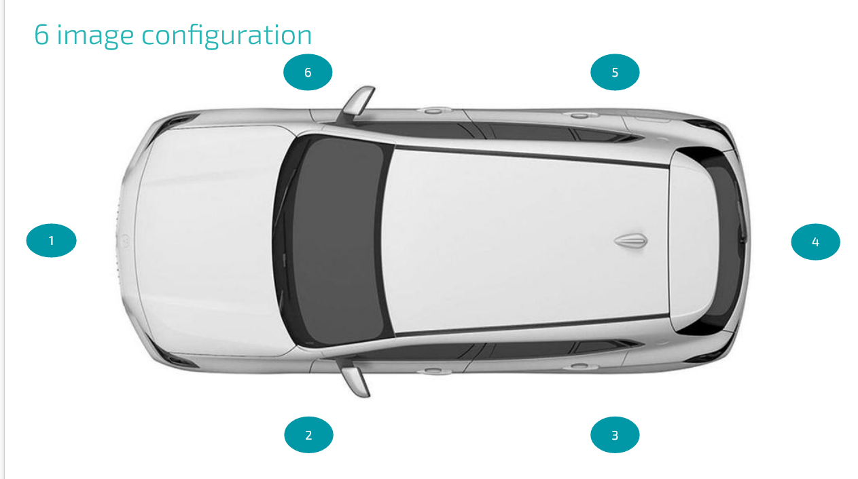

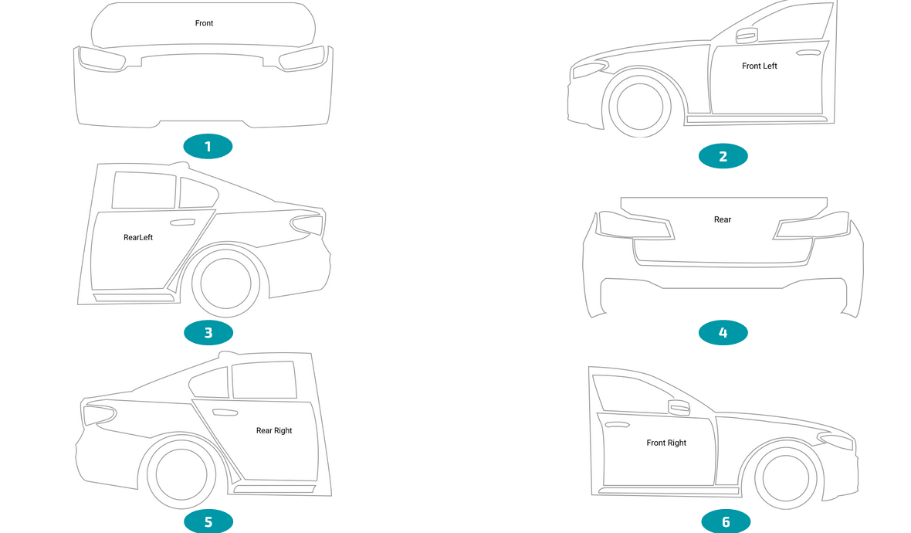

Description
- The above two images show a configuration of images in which a person is trying to capture images of a car from all sides to capture all the major parts of a car. There are 6 images / overlays of a vehicle in the above configuration. All image types have their name i.e front, frontleft, rearleft etc.

- Your task is to train a real time model that takes any image as input and identify which of these six above categories the image belongs to.

- It is not necessary for the test image to belong to any of the categories (images can also be random, that does not belong to any of these six categories).

- After model/logic is ready, convert it to tflite format and write the inference/prediction pipeline to process images from a test folder.

- Your model will be tested on our testing dataset. Name this file as test_predict.py.

- Your model will read images from a test folder and store the image name and its prediction in a pandas dataframe.

- The performance of the model will be the F1 score of each of the above six image type

Dataset : https://drive.google.com/file/d/12dXSLNwbArubn25XjcMBd-Pqw7go4ShN/view?usp=sharing

Dataset Format

The dataset consists of multiple folders with some images. All images are similar, they are just divided into folders for readability purposes. The annotation is done using the VIA VGG Tool. Annotations are stored folder wise in json format. The annotations are for almost all parts of the car. You can ignore a class if you think it is not necessary.

Sample structure of annotation

{'filename': 'scraped_Cou1uG_1654879781205.jpg',
'size': 0,
'regions': [{'shape_attributes': {'name': 'polygon',
'all_points_x': [462, 586, 582, 457],
'all_points_y': [135, 143, 216, 206]},
'region_attributes': {'identity': 'LCD', 'reading': ''}},
{'shape_attributes': {'name': 'polygon',
'all_points_x': [475, 533, 531, 473],
'all_points_y': [183, 188, 207, 202]},
'region_attributes': {'identity': panel_x'}}],
'file_attributes': {}}

Name of the image_file. Use this value for file name instead of the name of the key as vgg key is combination of filename and size

Regions This is the list of annotated objects.Every object has their own region and shape attributes. Shape attributes contain the coordinates of the object in the image. These are absolute pixel values. region attributes contain class name or ocr reading if necessary.

Deliverable

- The complete inference pipeline and tftile model(s) that are required to predict results on the testing dataset.

- Provide the training and data pre-processing scripts with comments if required for better understanding. Also, attach the screenshots for training logs.

- Description of dataset preparation, augmentation(if any), model used, training parameters/hyper-parameters. Name this file readme.txt.

All the above archived in one single .zip or .tar file named product_overlay_firstname_last_name for eg:
product_overlay_john_doe.tar.gz

Note:
Since the evaluation of your exercise will be done by us, it completely depends on whether we are able to run your test_predict.py. Share the instructions to complete the setup and run the file on a new system.

